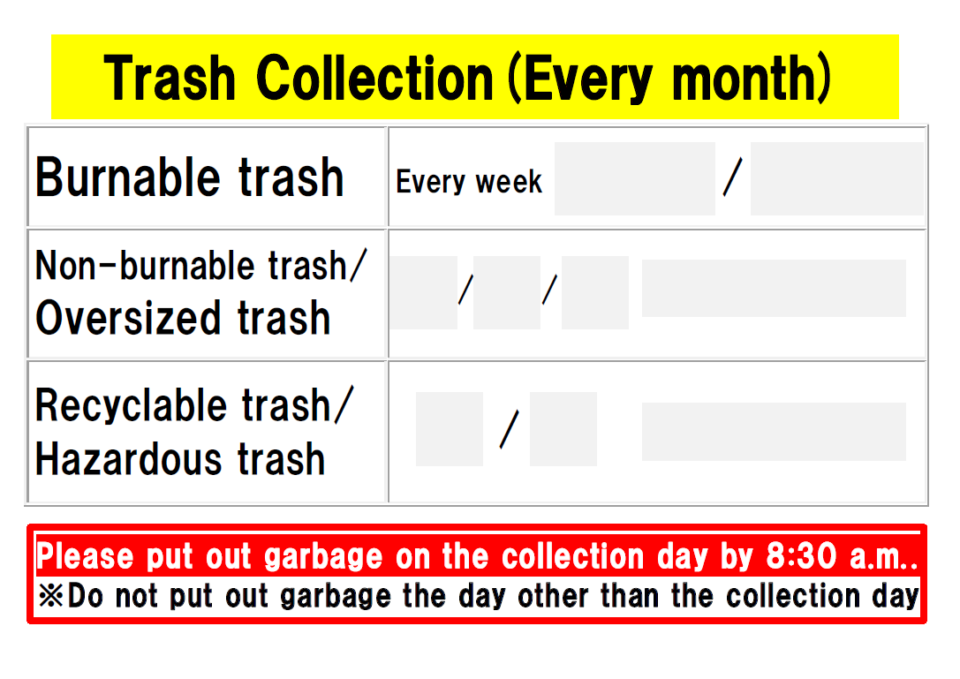

Friday

4th

2nd

Friday

5ｔｈ

３ｒｄ

１ｓｔ

Thurs.

Mon.